g++ -W -Wall -Wextra -pedantic gyak.cpp

Beolvasás consolerol
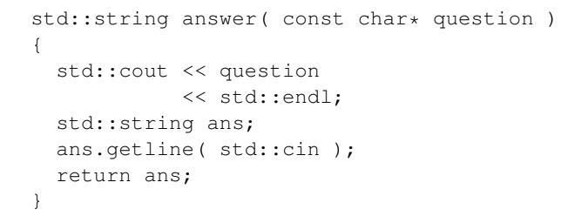
header guard vagy include guard.
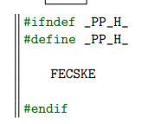
funktor
struct greater_int {
bool operator()(int a, int b) const {
return a > b;
}
};

